AAUW PALM BEACH COUNTY
POSTE HASTE
October 2013

OCTOBER MEETING
Saturday, October 19th
Tom Sawyer Restaurant
3208 Forest Hill Blvd (just west of Congress Ave on the south side)
$20.00 (CASH PLEASE!)

Shelley Vanna, Palm Beach County Commissioner will be the guest speaker.

PERSIDENT’S MESSAGE
Prez Mess October 2013

“Education is the most powerful weapon which you can use to change the world.” Nelson Mandela
Dear Members,
As you read this, I will be in South Africa on vacation. South Africa has been described as the “Cradle of Civilization,” and is probably best characterized by its multiethnic population and its high rate of poverty. Despite social and political problems, South Africans have pioneered many advances in STEM. Dr Christiaan Barnard performed the first human to human heart transplant, yellow fever vaccine was developed in South Africa and there is a renowned astronomy research facility there. An early internet security company was bought out by VeriSign, the authorization service we rely upon daily in our internet searches. South African history teaches us that despite obstacles, education is the key to improving society.
STEM (science, technology, engineering and math) is a primary focus of AAUW. Nationally, AAUW awarded 366 fellowships, grants and scholarships. Two of our branch members have been recipients, Maria Asencio and Dr. Bernadette Russell. Nationally, 250 girls entering eighth grade attended Tech Trek, AAUW’s STEM summer camps. We had four girls from Palm Beach County that attended AAUW-FL’s inaugural camp at UCF this past July.
AAUW Palm Beach County is planning to host a one-day hands on STEM conference for 200 middle school girls in February. The impact we could have takes my breath away. The event would feature mini workshops for the students lead by scientists, engineers and teachers. There would also be workshops for parents that focus on family relationships and parent responsibilities. We would like to focus all of our branch fundraising and activities around STEM.
Today I received notification that the newly released data from the U.S. Census Bureau shows that there has been no improvement in the gender wage gap. Women still earns 77 cents for every dollar their male counterparts earn. This disparity greatly impacts retirees, since social security benefits are calculated on earned income. Young women emerging from college with degrees are being forced to take lower paying positions and forced by necessity into employment outside their career choice.
My goal is to encourage every member of our branch to join AAUW’s “Two Minute Activist” that allows you to keep up to date with the issues important to you and helps you easily send a personalized email to your congressional representatives.
“No one is born hating another person because of the color of his skin, or his background, or his religion. People must learn to hate, and if they can learn to hate, they can be taught to love, for love comes more naturally to the human heart than its opposite.” Nelson Mandela
Susan

HIGHLIGHT OF AAUW EDUCATIONAL NEWS
Submitted by Betty Rigdon

Creating Classrooms of Justice: Teaching Gender Studies in Schools
Register for AAUW’s inaugural gender symposium on October 26, 9 am -5:30 pm in St. Louis at www.aauw.org/gender-studies/. Bringing together educators, administrators and resource providers. Discuss ways to bring gender and women’s studies to secondary classrooms. Features Ileana Jimenez, founder of “Feminist Teacher” blog. Teacher gender studies can reduce sexual harassment.
Listen to AAUW Senior Researcher Andresse St. Rose on NPR’s “Science Friday”. Discusses gender gap in science and math fields. www.sciencefriday.com/segment/08/16/2013/the-stem-gender-gap.html
Enhance your advocacy skills. Resources and how-to-guides from AAUW’s Public Policy and Government Relations Dept. www.org/resource/advocacy-how-tos-guides/
Recruit your alma mater to join AAUW as a college/university partner member. Check the College and University Partner Directory to see if your alma mater is already a partner. www.aauw.org/resource/ask-your-alma-mater-to-join-aauw/
Book lovers join Adelante! Book of the Month Club. 2013-2014 list available. www.aauw.org/resource/adelante-book-list. 30% discount at Feminist press www.aauw.org/membership/benefits/
National Conference for College Women Student Leaders (NCCWSL). Early registration opens Jan. 30. Ideas for branches and individuals to help fund the two-and-a-half day conference. www.nccwsl.org/states-branches/
POLITICAL POLICY
Submitted by Susan King
Congress returned from their 5 week recess on September 9. They had expected to work on several items: immigration reform, a new budget and raising the debt ceiling. They were sidetracked when Syria used poison gas on its citizens killing thousands.
Syria has shown signs of allowing United Nations inspectors to come in and verify that they are destroying their stockpiles of weapons.

October 1st is the beginning of federal fiscal year 2014. Many of the Affordable Care Act (Obama Care) regulations take effect in 2014. The House passed a budget bill that would fund the government only if all spending for the health care law is eliminated. All Democrats and some Republicans voted against this bill. However it passed 230 to 189. The bill will be sent to the Senate where it is expected to be voted down. If it should get to the President he will veto it.

The raising of the debt limit is expected to hard fought. If it is not passed the government will have to default on their bills. This would cause a shutdown of the federal government in a few weeks. If this were to happen soldiers would not be paid, parks and monuments would shut down, federal workers would go on unpaid furlough.
Air traffic controllers, border security guards, and other public safety officers would remain at work, Social security checks would go out. Medicare would still pay doctors.

The sequestration cuts in effect now have caused researchers to close laboratories and lay off researchers. Special education services have also been reduce or cut.

September 20 the House passed a bill reinstating SNAP (supplemental nutrition assistances program) also known as food stamps. It cut billions of dollars from the program saying the program had grown out of control... It would require adults between 18-50 years of age without minor children to find a job or enroll in a work training program in order to get benefits. It would also limit the time recipients could get benefits past 3 months for able bodied people who are working or preparing for work in a job-training program.
The bill is given little chance of advancing to the senate. None of the Democrats in the house voted for this bill.

The Department of Labor has extended basic labor protections to nearly 2 million home care workers who had not been covered by the Fair Labor Standards Act. This makes them now eligible for minimum wage and overtime premium pay.

In Florida, Governor Scott is again pushing for a purge of the voters rolls in order to eliminate voter fraud. Many of the county supervisors of elections are pushing back against this. They say the lists they are given of noncitizens do not give enough documentation to show fraud.

Please stay in touch with your legislators. You can use AAUW’s Two minute activist site or send emails or phone calls. There is a lot going on which will affect us all. Let your opinion and wishes be known.

HAPPY HOUR/TAPAS and TALK

Join us for lively discussions about politics, STEM and current events. Relax and enjoy a cocktail with friends. Bring a friend or co-worker. All are welcome.

Wednesday, October 30th, 6 pm @ BRIO in City Place
Wednesday, November 13th, 6 pm @ City Cellar in City Place.

CULTURAL AND SOCIAL ACTIVITIES
AAUW Palm Beach County would like to organize an outing to the new museum at the Wick, followed by a luncheon. This event would be held in early December. Anyone interested in participating or arranging this, please email Susan at svberlin@bellsouth.net, or MJ at mjrange@comcast.net

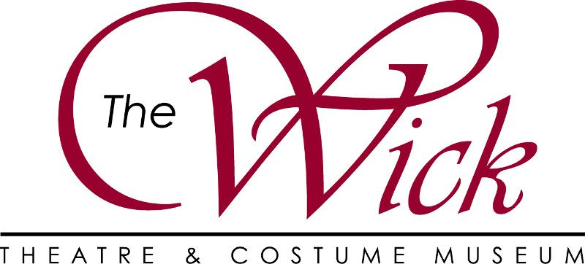

Boca Is ALIVE With The Sound of Music!!!!

Watch Our Video!!

Join us, as our inaugural season begins with the beloved Rodgers & Hammerstein classic "T“e Sound of Music." ”Our production opens this Thursday, September 19th. Subscriptions and single tickets available. Get yours today!!!!  Box Office Hours are:  M-F 10am-6pm  Saturday & Sunday 10am-4pm  561-995-2333  OR  Order online anytime at thewick.org | GET TICKETS

Our nationally acclaimed Costume Museum will officially open on November 5th. Please call the Box Office and book your reservation for your Broadway tour & luncheon.
The Wick Theatre & Costume Museum - –901 North Federal Highway - –oca Raton, FL 33487

COMMUNITY SERVICE
The Association for Abused Women and Children needs our help to help displaced families start anew. They need items for their thrift shop:
Pots and pans
Small appliances
Utensils
Linens and towels
Items can be dropped off at the Thrift Shop, 7110 S. Dixie Hwy, Tuesday – Saturday, 11 am – 3:30 pm. (561) 586-1888

Maureen Hurlbut has moved. Her new address is 1210 Colonial Ave. #807, Norfolk, VA 23517

