Poste Haste December 2016
AAUW PALM BEACH COUNTY BRANCH
Save the Dates!!
September 19
October 17
November 21
Information will be coming as to why …………..

Notes
Happy Happy December Birthdays!

Barbara Bailey
Virginia BrooksWrock
Fenee Russ

Join Us for Our Monthly Meeting Saturday,
December 10, 2016
Where: Holiday Party at
Atlantis Grill & Bar
When: Noon , Dec. 10
Directions: Atlantis Grill & Bar is located in the Shoppes of Atlantis on the northwest corner of Lantana Road and Congress Ave. No valet parking.

Please RSVP to:
Vmackk69@gmail.com or
Virginia (the Other)
561-271-5277 We must have an accurate head count to have adequate seating

1734 S. Congress Ave., Palm Springs, FL 33461
http://palmbeach-fl.aauw.net/ T: (561) 642-4720
Notes and Whatnots
Last month we had lunch at the eclectic Grato’s – good food and lots of fun. Afterward we went to the Norton Museum for an excellent and informative tour given by our own Carol Ann Khawly. While the museum is still undergoing renovations, Norton provides a minibus for patrons’ use. Not only did we enjoy the Norton’s excellent art displays, we learned quite a lot from Carol Ann about the art as well as the art of display!
This month we are having our annual Holiday Party! We will meet at the Atlantis Grill & Bar, 5805 S. Congress, Lake Worth, at noon to have lunch and a fun gift exchange. You will be able to order from the menu.
For the gift exchange, please purchase a new gift with a $10.00 maximum value that is not specifically a Christmas gift, such as tree ornament. We are cognizant of the fact that not all our members celebrate Christmas.
Please RSVP for the Holiday Party - it is really important for us to provide an accurate head count to the Atlantis Grill & Bar.
Have you checked out your Branch’s Facebook page? If not, you are missing an opportunity to keep up with the latest happenings.

Educational and Legal News from AAUW National
Compiled by Betty Rigdon

AAUW Receives Grant from Symantec Concerning Cybersecurity
1 million cybersecurity jobs currently open in US
Currently women are 26% of computing workforce and 10% are cybersecurity professionals
Symantec gave AAUW a $100,000 grant to develop cybersecurity classes for middle school girls
interested in STEM
This grant will expand AAUW Tech Trek program
Cybersecurity class piloted at Bowling Green University in Ohio, Stanford University in California
University of California, Irvine plus 13 AAUW Tech Trek camps
Symantec has goal to engage 1 million students in STEM by 2020
AAUW Action Fund Capitol Hill Lobby Corps since 1972
Meets every Thursday while Congress in session
Members go to congressional offices
Agenda includes gender equity in education, moderate jurists for federal courts and measures
to improve economic security
Has had impact in the past on legislation concerning education, civil rights, reproductive rights
and economic security
2017 AAUW National Convention June 14-17, 2017, Washington, D.C.
Registration now open- largest discount on price if paid by Jan. 14, 2017
Includes workshops and roundtables
NCCWL- National Conference for College Women Student Leaders
Conference May 31- June 3, 2017, University of Maryland, College Park
Registration opens Dec. 5, 2016
2016 Empowering Gift Ideas for Feminists
Shop by age groups from zero- 3 to 65+
Most gifts are $25 or less
Shop online at www.aauw.org/2016/11/14/gifts-for-fearless-feminists/

Latest from Maurcy
AAUW believes that women deserve a seat at the table in peace negotiations. This week, the U.S. House of Representatives passed the bipartisan Women, Peace, and Security Act(WPS Act), which would ensure that women’s voices are heard when decisions about conflict prevention are being made.
We need you help to push this bill across the finish line by urging the U.S. Senate to pass the WPS Act! Email your Senators now.

Some More Notes
Atlantis Grill and Bar – is the last business on the northern side of the shopping center; we will be in the front toward the left; small airport across Congress
Cake Garden Bakery and Tea House – 1790 N Congress Avenue, Suite 200, Boynton Beach. Cake Garden is located just south of Gateway on the East side (ocean side); you can turn East onto Reanaissance Drive and go to the first break between the commercial buildings and turn left; Jersey Mike’s
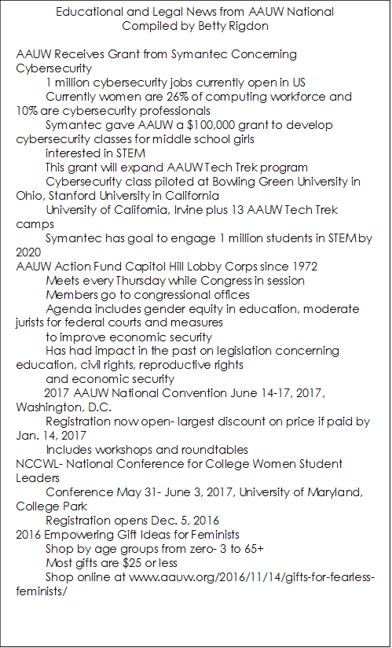

will be on the left; turn right and pass Sage Dental of Central BB go to St. 200; it will be near Mattress Land. The signage is not very noticeable, but the food is worth the search.
Hacienda Restuarant– 14280 S Military Trail, Delray Beach; Southeast corner of Military and Atlantic; There is a Bed Bath and Beyond, a Marios, nearby in the shopping center; food is not your usual “mild, medium, hot” Mexican food – it’s really tasty; order from the menu.
BOOK CLUB NEWS
By Virginia Farace

The Third Friday Book Club had lunch at Atlantis Grill on Dec 2 to celebrate the holidays. No book was discussed but the title for January 20 was selected. Beverly Agee will moderate the discussion of Miller’s Valley by Anna Quindlen. More about the book in the January newsletter.
As always, new members are welcome. If you are interested, please email Virginia at AAUWFLfarace@gmail.com to receive a copy of the Book Club Guidelines and a list of past titles.
Here are pictures of some of the Book Club members as they party together!
We are supporting an orphanage in Haiti –
Proje-Timon
They are in desperate need of toothpaste and toothbrushes, but also appreciate small toys, barrettes, writing and coloring pencils (crayons melt). Your donations can be dropped at Dr. Susan Berlin’s office.
If you want more information you can call Dr. Jean-Jacques Velouse
561-351-5625

Now is The Time
Time to: Pay Annual Dues
Dues Amount: $75.00
Payment Made To:
Palm Beach County AAUW
Send Payment to:
Susan King
731 S. Lakeside Drive
Lake Worth, FL 33460
You can also renew online

