Poste Haste March 2017
AAUW PALM BEACH COUNTY BRANCH
Save the Dates!!
September 19
October 17
November 21
Information will be coming as to why …………..

Notes
Happy Happy March Birthdays!

Susan King
Amy Schwed

Join Us for Our Monthly Meeting Saturday,
March 18, 2017

Where: Paradiso Restaurant, Lake Worth
When: Registration starts at 11:00 a.m.
Directions: 625 Lucerne Ave. Federal Hwy to West onto Lucerne. Remember Lucerne is one way heading west. (away from the ocean)

Please RSVP to:
Susan Berlin with your reservations or with any questions.
aauwflberlin@gmail.com

1734 S. Congress Ave., Palm Springs, FL 33461
http://palmbeach-fl.aauw.net/ T: (561) 642-4720
Notes and Whatnot
An interesting and fun time was enjoyed at Loxahatchee National Wildlife Refuge. Good presentation by Wildlife professional followed by a walk where we were able to use our new knowledge to enhance our enjoyment. We followed up with a yummy lunch at Alabama Joes. We didn’t lose anyone in the Refuge or on the way to Alabama Joes!
This month our meeting is at Paradiso’s and it will be our fund raiser. During the Board Meeting Sharon Trost and Maurcy Selko shared how impressed they had been with the 7 girls who want to attend Tech Trek. The girls were bright, motivated, and excited at the camp’s possibilities. Specially moving were the parents for whom the $50 family contribution was going to be a challenge. These parents are convinced that Tech Trek will be so important to their daughters that they will be sure to save the money. Since Tech Trek is a major focus of our find raiser, we need to get donations to enable all 7 girls to go!
Included in this issue, is the reservation form that Susan needs for your reservation, plus a letter to share with merchants when soliciting donations.
Our fundraising dollars also go toward NCCWSL (National Conference for College Women Student Leaders. May 31-June 3 a workshop will be held at University of Maryland to train and foster leadership qualities in college women .This is an excellent opportunity for these women.

Did you know…..
AAUW was started with only 17 women….

AAUW has Fellowships for women pursuing full-time study to complete dissertations, conducting postdoctoral research full time, or preparing research for publication for eight consecutive weeks.

It is amazing what 17 women can accomplish.

Your Branch Needs
People who have experience writing grants. We are applying for some grants for Tech Trek Camp and need help with the buzz words used in grant writing. Contact Susan Berlin if you know someone-
561-642-4720
AAUWFLberlin@gmail.com

Request – If you know of fundraising that is quite effective will you please contact one of the Board members? We are looking for new ways to add to our donations!!
Change in email or phone be sure to let us know!

AAUW Washington Update – From Maurcy Selko

On March 8, AAUW will stand in solidarity with the millions of women across the country and around the world committed to advancing gender equality. Whether by observing international Women’s Day, participating the “day without a woman” general strike, or taking action to advance policies that empower women and girls, AAUW members will observe March 8 not as a day “off” but as a “day on”. Women cannot afford to wait for equality, and it won’t happen without our mobilized action. As a visible sign of our solidarity, all AAUW members are urged to wear something red on March 8.
Did You Know?
Bring your business cards, brochures, etc. to the fundraiser. There will be a place to display them.

Our Annual Branch Fundraiser will be March 18. We will be raising funds for the Tech Trek Camp – this is a very important way to introduce middle school girls to the tech field. So start thinking about who you will invite to this critical event!

2017 AAUW National Election --- One Member, One Vote
AAUW members will receive their voter information in early April by e-mail and mail with the Spring AAUW Outlook! Candidate slate, bylaws proposals, Public Policy Program proposals, and resolutions will be published in the Spring issue of AAUW Outlook. And don’t forget to check for the latest updates on the AAUW National Election web page.

Happy Hour Social
Dinner Possible Too!
April 5, 2017 a Happy Hour at the Beach Club on the Waterfront at Lake Worth address is 1 7th Ave.North, Lake Worth 33460. We will meet beginning around 5:30 p.m. going until you want to leave! You can also order dinner there. This venue is commonly referred to as Lake Worth Golf Club.

What Can I Do Locally? How about contacting local governances and sending an email suggesting porta pottys around town? Since we have decided homelessness is acceptable, and since many are immigrants without vaccinations, this becomes a potential health issue for all of us. There is a reason we have sewage system with treatment. So it seems common sense dictates we have these facilities available. And sure, maybe some will be misused, but the positive far outweighs the negative on this issue.

Educational and Legal News from AAUW National
Compiled by Betty Rigdon

Equal Pay Day- April 4
White women earn 80% of what men earn
Change is slowly coming- at current rate salaries will be on par by 2052
Equal Pay Days for other women- Asian-Americans (March), African-Americans (August)
Native Americans (September), Latinas (October)
Consider contacting your representatives in Congress about this inequality
Join movement to #Stand Up to Sexism
Online movement to show that participants do not accept sexism
Organize, protest, and push back against gender inequality
Download printable flyer www.aauw.org/files/2017/01/stand-up-to-sexism-sign.pdf
Title IX-federal law prohibits sex discrimination in schools receiving federal funds
Schools receiving funding must have a local coordinator
Local coordinators are:
Palm Beach County Schools- June Eassa, june.eassa@palmbeachschools
Florida Atlantic University, Boca Raton- Ande Durojaiye, adurojaiye@fau.edu
Nova Southeastern University, Palm Beach- Gay Holliday, gayhol@nova.edu
Palm Beach Atlantic University- Mona Hicks, Mona_Hicks@pba.edu
Palm Beach State College- Mareta Iosia-Sizemore, iosiam@palmbeachstate.edu
Alumnae Recognition Awardee at 2017 National Convention- Tererai Trent, PhD from Zimbabwe
Leads global charge for quality education and women’s rights
Read more at www.tereraitrent.org/ or Twitter: @Tererai Trent
Judy Woodruff to speak at 2017 National Convention
Co-anchor and managing editor of PBS NewsHour
Founding co-chair of International Women’s Media Foundation which promotes and
encourages women in communication industries worldwide

http://

Membership News
Any guest who attends a meeting and joins at that meeting pays one-half of State and National dues for the first year’s membership. This makes the total year’s membership $44.50. This is only for the initial year’s membership.

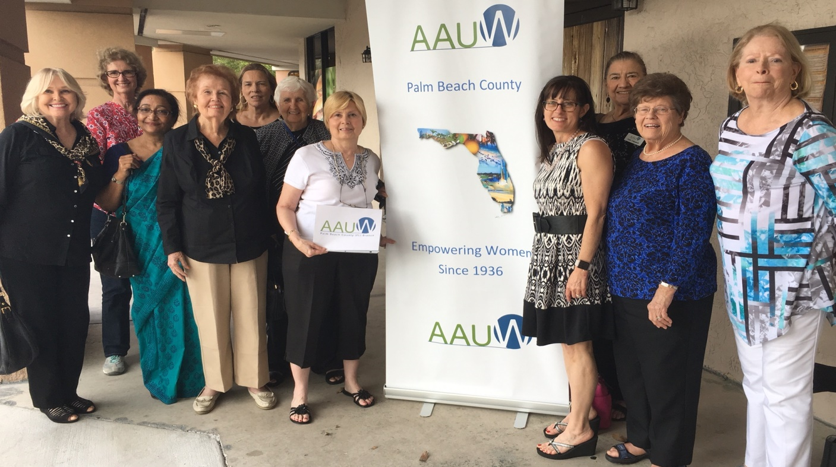
Our Own Women’s March in Delray Beach After Luncheon
Smart Start
Smart Start is an excellent program AAIW offers to young women starting out on their career path. Susan Berlin will be offering this at Lynn University on April 4, 2017. Susan can use some back up that evening, not as a presenter but helping people sign in, passing out information, etc. If you can help Susan on April 4, please contact her at:
Susan Berlin
aauflberlin@gmail.com
561-685-2557 (H)
561-642-4720 (W)
Susan is incredibly appreciative for any help you can offer.

AAUW Palm Beach County
Empowering women and girls since 1936

Dear Merchant,

The American Association of University Women (AAUW) is a powerful community that empowers women and girls through advocacy, education, philanthropy and research.

Our annual fundraiser will be held on Saturday, March 18, 2017, at Paradiso Ristorante in Lake Worth. Proceeds benefit AAUW Funds, a 501(c)(3) entity and support:

- Tech Trek Florida, a week-long STEM camp for eighth grade girls. This interactive program allows participants to explore the wonders of science, technology, engineering and math and encourages girls to pursue a career in STEM.
- Scholarships for college and university student leaders to attend the National College Conference for Women Student Leaders (NCCWSL) in Washington, D.C. This conference fosters leadership skills and encourages community involvement.

Your support would be greatly appreciated. Please consider donating a gift certificate or item for our auction. The success of our fundraiser depends upon the generosity of our community and people like you.

Thank you for your consideration

AAUW-Palm Beach County
1734 South Congress Avenue
Palm Springs, FL 33461
561.642.4720
FAX 561.967.4427

http://palmbeach-fl.aauw.net/

Palm Beach County Branch Fundraiser
Dear Members,
AAUW Palm Beach County’s fundraiser will be held on Saturday, March 18, 2017, at 11:00 am at Paradiso Restaurant. Tickets are $50.00 each. Please prepay your reservation to expedite check-in.
Return this reservation form, listing your guests’ names, along with the name of any other member with whom you would like to be seated. Everything possible will be done to accommodate your requests. Please reserve as soon as possible.
Luncheon includes a choice of entrees, coffee or tea, and dessert. A cash bar will be available.
Member Name _________________________________________________________________

Guest(s) Name(s)_______________________________________________________________

_____________________________________________________________________________
Total # of guests ______ X $50.00 per ticket= total amount enclosed $_____________________

I would like to be seated with: _____________________________________________________________________________

_____________________________________________________________________________
Make check payable to AAUW Palm Beach County

If you are unable to attend, please tell Susan Berlin. A monetary contribution is entirely tax deductible and will be greatly appreciated. The check should be made payable to “AAUW.”
Return to Susan Berlin, 1734 South Congress Avenue, Palm Springs, FL 33461
For additional tickets or further information: (561)642-4720 or svberlin@bellsouth.net

Save the Dates!

March 9 UN International Women’s Day – everyone wear red
March 18 11:00 a.m. -- Fundraising luncheon at Paradiso Ristorante, Lake Worth
April 4 Start Smart at Lynn University – Susan Berlin can use some help so call her to volunteer
April 5 5:30 p.m. Happy Hour at the Beach Club on the Waterfront at Lake Worth – address 1 7th Ave. North, Lake Worth 33460 - You can eat dinner too
April 22 Noon – Hacienda -- Annual Meeting
May 20 Noon – Callaro’s, Lake Worth -- Installation of Officers
Much more information will be forthcoming. Keep your eye on Poste Haste for the latest

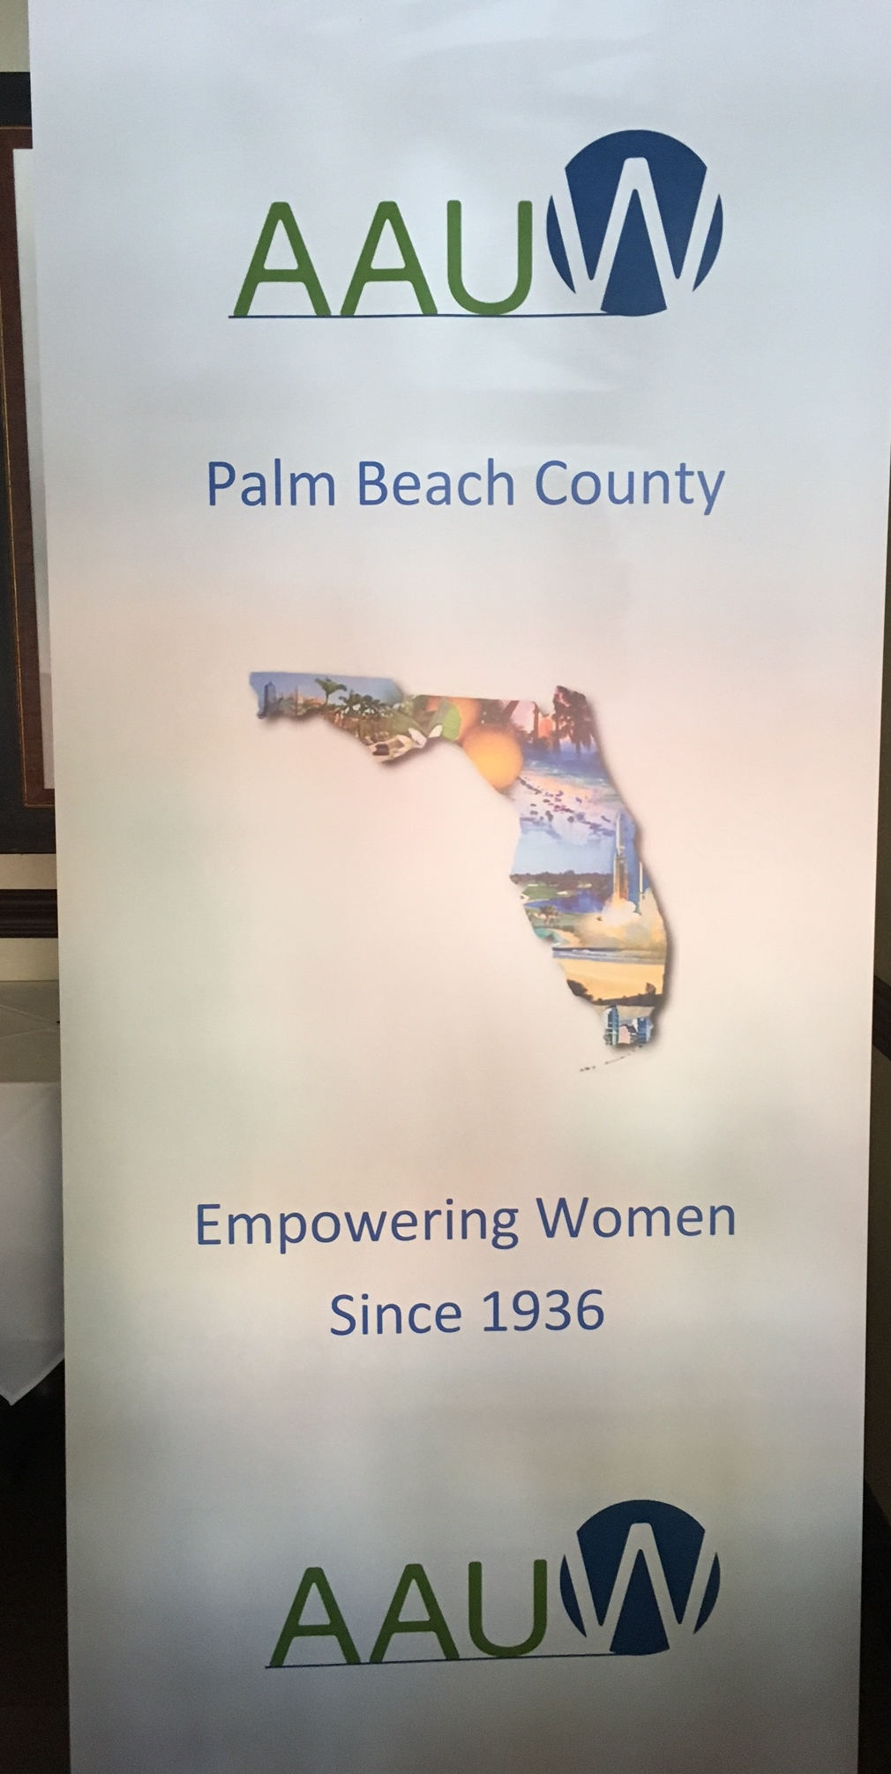
Beautiful New Branch Banner !!
2016-17 Officers
President: Susan Berlin
Program: Donna Artes and Beverly Agee
Membership: Barbara Wagner and Deborah Nesbit
Finance: Susan King
Communications: Virginia Brooks and Sharon Trost
Development: Betty Rigdon
Public Policy: Maurcy Selko
Secretary: Virginia Farace

