Poste Haste January 2017
AAUW PALM BEACH COUNTY BRANCH
Save the Dates!!
September 19
October 17
November 21
Information will be coming as to why …………..

Notes
Happy Happy January Birthdays!

Francesca Huneeus

Join Us for Our Monthly Meeting Saturday,
January 21, 2017

Where: Hacienda
When: Noon , January 21
Directions: Military Trail heading south to Atlantic Ave in Delray Beach. Hacienda is located in a shopping center at the southeast corner of Atlantic and Military. So turn left onto Atlantic and turn right into the shopping center just after gas station. Hacienda on the left.

Please RSVP to:
Vmackk69@gmail.com or
Virginia (the Other)
561-271-5277 We must have an accurate head count to have adequate seating

1734 S. Congress Ave., Palm Springs, FL 33461
http://palmbeach-fl.aauw.net/ T: (561) 642-4720
Notes and Whatnots
December’s Holiday Gathering was loads of fun, although travel to the Atlantis Grill was challenging due to a jackknifed truck on I95 which diverted many extra cars onto Congress. But we persevered and all arrived safely in time to order lunch, exchange gifts and holiday cheer! Traffic had mostly cleared by the end of the luncheon, giving us a clear trip home with full stomachs.
January will offer a social Tea for us to enjoy on January 13 at the Cake Garden Bakery and Tea House at 179 N Congress Ave., Suite 200, Boynton Beach. The Tea begins at 4p.m. Then our monthly meeting will be at Hacienda in Delray Beach on January 21 starting at noon. We do need RSVPs for both in order that we have adequate seating.

Did you know…..
AAUW was started with only 17 women….

AAUW has Fellowships for women pursuing full-time study to complete dissertations, conducting postdoctoral research full time, or preparing research for publication for eight consecutive weeks.

It is amazing what 17 women can accomplish.

Maurcy Selko’s Supreme Court Report
The January calendar for the US Supreme Court was released this week. The justices will hear nine arguments over five days of oral arguments throughout the month. Included on the schedule are cases regarding educational benefits for students with disabilities, credit card surcharges, and the rights of tribal workers seeking damages in employment cases.
As Supreme Court nominee Merrick Garland still awaits a hearing, there are dozens of lower court nominations that are still pending. Terrence Campbell, a nominee to the federal bench in Kansas, withdrew his name from consideration and noted that

Your Branch Needs
People who have experience writing grants. We are applying for some grants for Tech Trek Camp and need help with the buzz words used in grant writing. Contact Susan Berlin if you know someone-
561-642-4720
AAUWFLberlin@gmail.com

Change in email or phone be sure to let us know!

Maurcy’s Report contd.

It is apparent that the U.S. Senate will not have time to confirm him. Sen. Jerry Moran (R-KS) stated that he is disappointed that Campbell could not be confirmed before the election. Similarly, a federal judge nominee from Idaho, David Nye, is one of 20 federal district judge nominees awaiting confirmation. Sens. Mike Crapo (R-ID) and Jim Risch (R-ID) issued statements saying they hope Nye will be re-nominated and confirmed in 2017.

Did You Know?
Melissa Sackl’s husband plays in the Mid-Shift Blues Band and they will be playing Jan. 13 at the South Florida Fair at 9p.m.
Come enjoy the performance and be a groupie after the show.

Educational and Legal News from AAUW National
Compiled by Betty Rigdon
Join AAUW Delegation at Women’s March
Rally for women’s rights
Jan. 21, 2017, 10:00a.m. in front of Capitol
Ninth Annual AAUW Art Contest now open
Submissions due by Jan. 31, 2017
Must login with member ID at www.aauw.org in order to enter
Register for AAUW National Convention by Jan. 14, 2017 for best rate
Convention to be held June 14-17 in Washington, D.C.

Our Annual Branch Fundraiser will be March 18. We will be raising funds for the Tech Trek Camp – this is a very important way to introduce middle school girls to the tech field. So start thinking about who you will invite to this critical event!

January 15 - March 15 new members pay half dues. Any guest attending an event who joins at the event gets half dues also.

What Can I Do Locally? How about contacting local governances and sending an email suggesting porta pottys around town? Since we have decided homelessness is acceptable, and since many are immigrants without vaccinations, this becomes a potential health issue for all of us. There is a reason we have sewage system with treatment. So it seems common sense dictates we have these facilities available. And sure, maybe some will be misused, but the positive far outweighs the negative on this issue.

Lois Frankel health care rally at Found Care 2330 S Congress, WPB 2pm January 15. North of Susan B’s office.

Latest from Maurcy
AAUW believes that women deserve a seat at the table in peace negotiations. This week, the U.S. House of Representatives passed the bipartisan Women, Peace, and Security Act (WPS Act), which would ensure that women’s voices are heard when decisions about conflict prevention are being made.
We need you help to push this bill across the finish line by urging the U.S. Senate to pass the WPS Act! Email your Senators now.

Anyone Interested??
The Maltz Theater is offering The Producers and we thought January 28 would be a good time to go. If you are interested call Susan Berlin 561-642-4720. Tickets are $68.00

Some More Notes
Cake Garden Bakery and Tea House – 1790 N Congress Avenue, Suite 200, Boynton Beach. Cake Garden is located just south of Gateway on the East side (ocean side); you can turn East onto Reanaissance Drive and go to the first break between the commercial buildings and turn left; Jersey Mike’s will be on the left; turn right and pass Sage Dental of Central BB go to St. 200; it will be near Mattress Land. The signage is not very noticeable, but the food is worth the search.
Hacienda Restuarant– 14280 S Military Trail, Delray Beach; Southeast corner of Military and Atlantic; There is a Bed Bath and Beyond, a Marios, nearby in the shopping center; food is not your usual “mild, medium, hot” Mexican food – it’s really tasty; order from the menu.

http://

Bylaws Amendments
At its January meeting, the Board of Directors approved a recommendation that the following Bylaws Article be amended by the membership. This will be discussed at the January 21 meeting and the vote will take place at the February 18 meeting.
ARTICLE XI. BRANCH MEETINGS
a. Branch Meetings. There shall be at least seven (7) five (5) meetings of Branch members each year.
b. Annual Meeting. An annual meeting of the Branch shall be held during the month of April Spring, the exact time and place determined by the board. The annual meeting shall elect officers, fix dues, amend bylaws if necessary, receive reports of officers, committees and task forces, and conduct such other business as may properly arise.
c. Quorum. Fifteen percent (15%) of the members of the Branch shall constitute a quorum.

Branch bylaws may be amended at any regular Branch meeting by a two-thirds (2/3) vote of those present and voting, provided notice of the proposed bylaws amendment shall be sent to the entire membership at least two weeks prior to the applicable meeting.

BOOK CLUB NEWS
By Virginia Farace

The Third Friday Book Club will meet at 2 pm on January 20 at the Palm Springs Library. Beverly Agee will moderate the discussion of Miller’s Valley by Anna Quindlen.
Filled with insights that are hallmarks of Anna Quindlen’s bestsellers, this extraordinary novel is about a woman coming of age, as she unearths secrets about her family and her town, and surprising truths about herself.
For generations the Millers have lived in Miller’s Valley. Mimi Miller tells about her life with intimacy and honesty. As Mimi eavesdrops on her parents and quietly observes the people around her, she discovers more and more about the toxicity of family secrets, the dangers of gossip, the flaws of marriage, the inequalities of friendship and the risks of passion, loyalty, and love. Home, as Mimi begins to realize, can be “a place where it’s just as easy to feel lost as it is to feel content.”
Miller’s Valley is a masterly study of family, memory, loss, and, ultimately, discovery, of finding true identity and a new vision of home. As Mimi says, “No one ever leaves the town where they grew up, even if they go.” Miller’s Valley reminds us that the place where you grew up can disappear, and the people in it too, but all will live on in your heart forever.
As always, new members are welcome. If you are interested, please email Virginia at AAUWFLfarace@gmail.com to receive a copy of the Book Club Guidelines and a list of past titles.
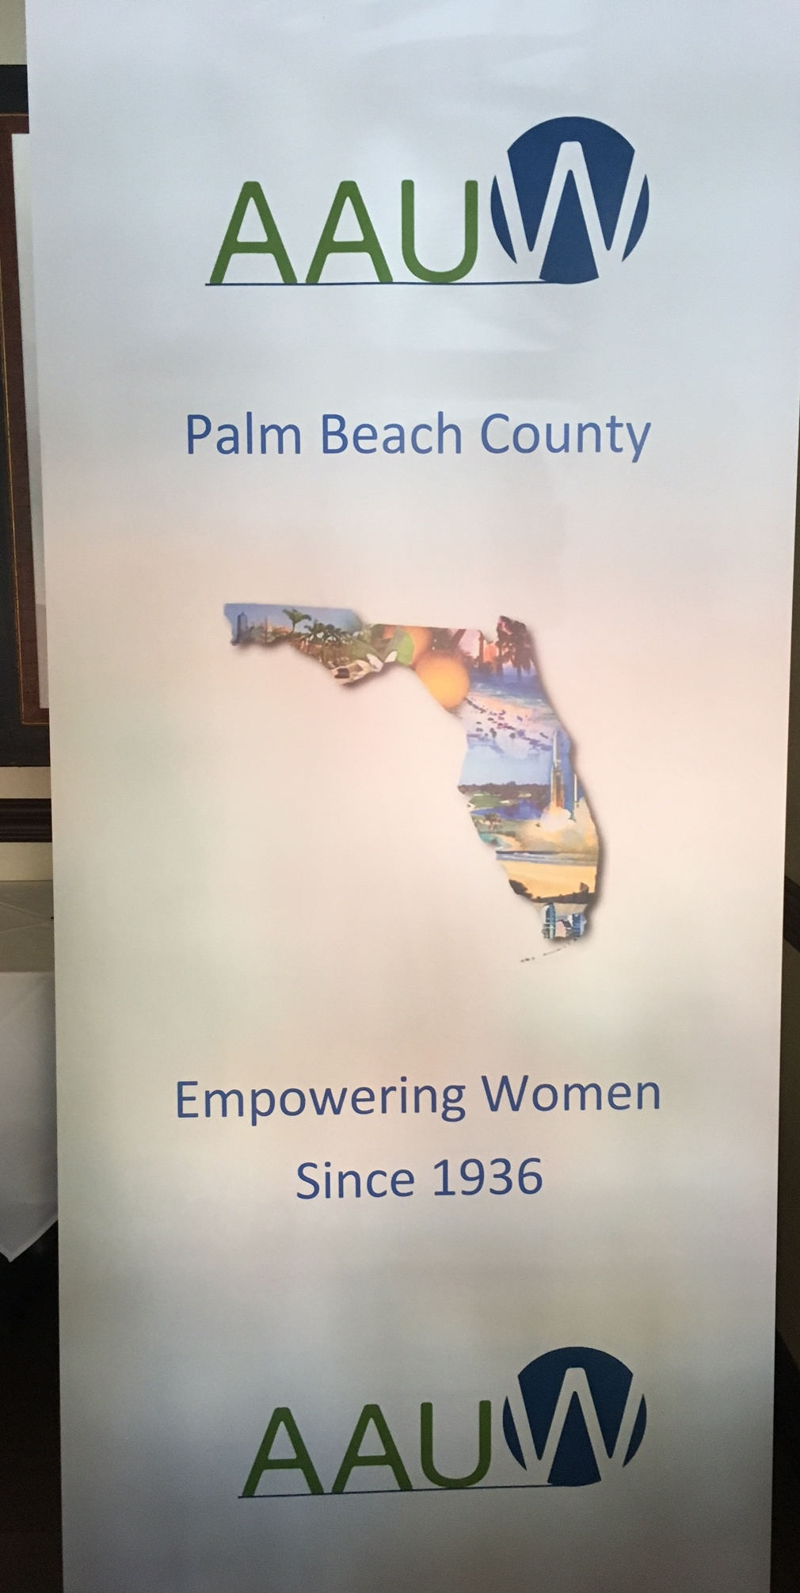

Beautiful New Branch Banner!!!
Save the Dates!

January 13 Special Event – Tea at Cake Garden Bakery and Tea in Boynton Beach
January 21 Monthly Meeting at Hacienda in Delray Beach, 14280 S Military Trail,
Delray Beach

February 18 11:00 am -- Field trip at Loxahatchee Refuge $5.00 donation at the gate.
1:00 pm lunch at Alabama Joe’s in the Canyon Town Center on Boynton Beach Blvd and Lyon’s Road
March 18 Noon -- Fundraising luncheon at Paradiso Ristorante, Lake Worth
April 22 Noon – location TBA -- Annual Meeting
May 20 Noon – Callaro’s, Lake Worth -- Installation of Officers
Much more information will be forthcoming. Keep your eye on Poste Haste for the latest
2016-17 Officers
President: Susan Berlin
Program: Donna Artes and Beverly Agee
Membership: Barbara Wagner and Deborah Nesbit
Finance: Susan King
Communications: Virginia Brooks and Sharon Trost
Development: Betty Rigdon
Public Policy: Maurcy Selko
Secretary: Virginia Farace

